Software Requirements Specification

for

***Schedule***

**Version 2.0 approved**

**Prepared by Mohamed Osama Ahmed**

**Faculty of Engineering Fayoum University**

**23/10/2018**

**Table of Contents**

Contents

*1.* *Introduction* 3

*1.1* *Purpose* 3

*1.2* *Product Scope* 3

*1.3* *Glossary* 3

*2.* *Overall Description* 4

*2.1* *System Environment* 4

*2.2* *Product Functions* 5

*2.3* *User Classes and Characteristics* 5

*2.4* *Operating Environment* 5

*3.* *External Interface Requirements* 5

*3.1* *User Interfaces* 5

*4.* *Other Nonfunctional Requirements* 10

*4.1* *Safety Requirements* 10

*4.2* *Security Requirements* 10

**Revision History**

|  |  |  |  |
| --- | --- | --- | --- |
| **Name** | **Date** | **Reason for Changes** | **Version** |
|  | 13/10 |  | 1.0 |
|  | 23/10 |  | 2.0 |

# Introduction

## Purpose

The purpose of this document is to give a detailed description of the requirements for the “Scheduler” web application. It will illustrate the purpose and complete declaration for the development of system. It will also explain system constraints, interface and interactions with other external applications. This document is primarily intended to be proposed to a customer for its approval and a reference for developing the first version of the system for the development team.

## Product Scope

Scheduler is a web application for making college timetable for instructors in which it relates subject to suitable instructor Depending on certain criteria. Admin should supply professor’s information like name, age, Profession, specification, seniority and etc. for each instructor. After that by ending Deadline, web application is going to do its function relying on the information which was obtained and after reviewing through responsible, and start dividing instructor stuff on Curriculum to reach that every instructor has taken the right subject and avoiding the conflict because of a lot of things like increasing of stuff in specific field or decreasing or anything else through relying on priority.

Furthermore, the web application needs both Internet and university e-mail to log in it and start insert the desires in viewed table and finally after receiving these information web applications is going to display the available subjects to choose limited number of them and save the request.

## *Glossary*

|  |  |
| --- | --- |
| Term | Definition |
| Database | Collection of all information monitored by this system. |
| Software Requirements Specification | A document that completely describes all the functions of a proposed system and the constraints under which it must operate. For example, this document. |
| Admin/Administrator | System administrator who is given specific permission for managing and controlling the system. |
| User | The Instructor in the faculty with all academic position. |

# Overall Description

This section will give an overview of the whole system. The system will be explained in its context to show how the system interacts with other systems and introduce the basic functionality of it. It will also describe what type of stakeholders that will use the system and what functionality is available for each type. At last, the constraints and assumptions for the system will be presented.

## System Environment

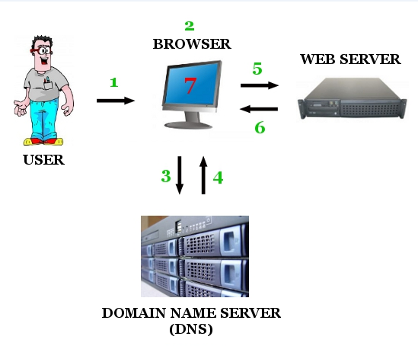 This system will consist of two parts: one web application and one web portal. The web application  
will be used to insert and view information about the staff, locations and times while the web server will be used for storing collected in database on it to be available always.

Since this is a data-centric product it will need somewhere to store the data. For that, a database will be used. Web application will communicate with the database, however in slightly different ways. The user will only use the database to get data while Admin will also add and modify data. All of the database communication will go over the Internet.

The web application will need to get all data which applied by users whether admin or instructor, which in turn store all information on database on web server then after dead line come it will start processing these data and applying some algorithms on it to get information depended on the desires of instructors. then web server will send information to be viewed for users on web application.

## Product Functions

* User enters the e-mail name and password.
* then they should insert their desired subjects and timetable days and.
* App will try to satisfy all requirements of the users.

and prioritize seniors using logical and mathematical algorithms.

* App will view the outputs in a table.

## User Classes and Characteristics

There are two classes of Users

1. Admin: Who can access on all features in the web application starting by adding other admins to cPanel passing by entering basic information of each instructor reaching to entering Halls, courses and its times.
2. Instructor: who can access on his preferences by adding, deleting or modifying it. He also can choose the times that are suitable for him.

## Operating Environment

Any operating system can surf the internet well.

# C:\Users\Ahmed\Desktop\SRS-1.JPGExternal Interface Requirements

## User Interfaces

Simple login page, there are two types of users;

1) IT admins. If the e-mail and password entered are saved in the Admin table in database, Scene A will be opened as it's admin-authorized only.

2) If the e-mail and passwords aren't saved in the admin table then we begin to check their existence in the Users’ table. If they exist, scene-A1 will be opened

3) If e-mail and password don't exist at both tables, it will prompt the user.

**If the user is IT Admin**

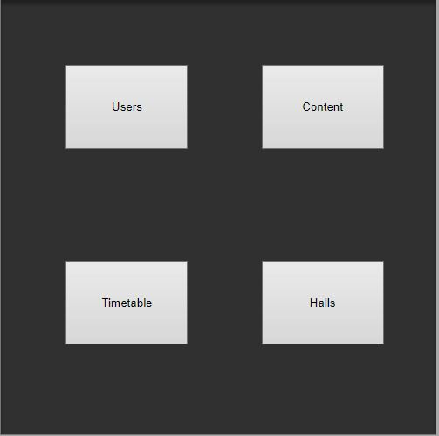

This page will open for him to choose any category of these which are available for him. And these are all validities in this web application

Users Section A.1

Content Section A.2

Timetable Section A.3

Halls Section A.4

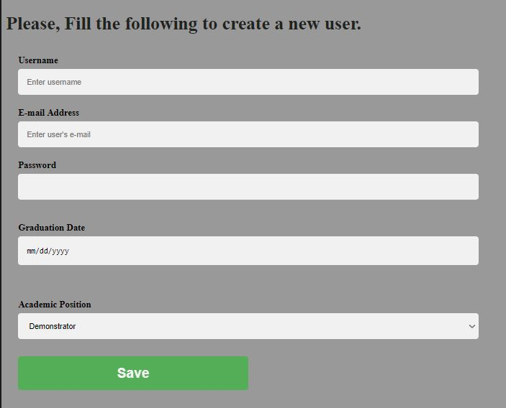

**A.1**

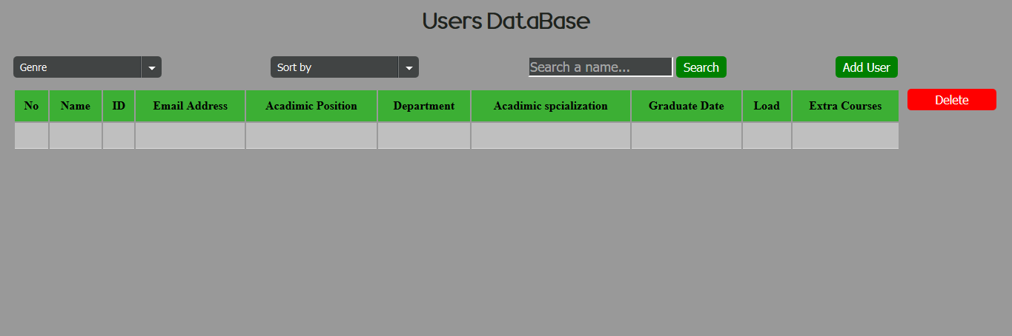

This page displays all the users and their information (Name – ID - Email Address - Academic Position- Department- Academic Specialization- Graduate Date- Load- Extra courses).

**This page can only be accessed by Admins**.



You can manipulate the table by the two select above the table (Sort by-Genre).



You can search a name by writing the name inside the search box then press the button "Search".



You can add a new user by pressing the button "Add User" which leads to another page (A1-1).



You can also delete any user by marking them then press the button "Delete".

**A1.1**

In this page the admin can add new users and his information such as (first name, last name, id, email address, date of birth, academic position, graduate date, phone number, academic specialization, min load and extra courses)

**A.2**

This page shows subjects and describes its properties like:

1. Its code.
2. Department.
3. Grade.
4. Weekly lectures Hours.

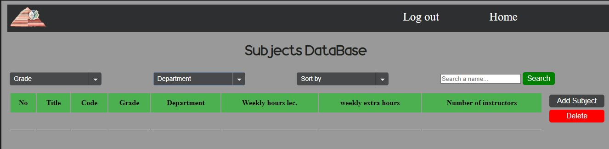

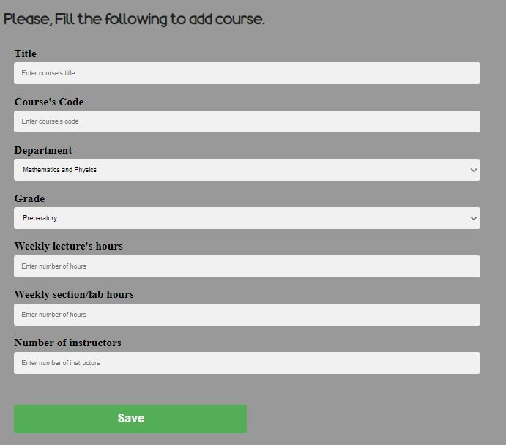

**A.2.1**

In this page user can add a subject or course. He can also add its Specifications like:

1-Name.

2-Code.

3-Grade and department.

4-Weekly lecture hours.

5-Weekly section/lab hours.

6-Number of instructors

**A.3**

In this page admin can see what intervals that he added before in last page (durations for each days and grade) in table and he can go to the last page to add more intervals. After clicking on the Add-Times button, section A.3.1 will open.

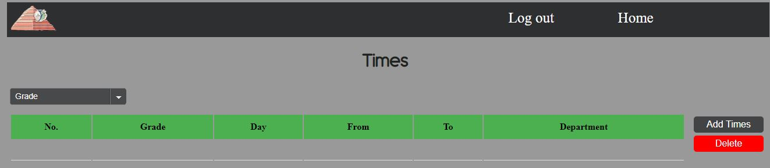

Other Nonfunctional Requirements

## Safety Requirements

You should write your correct phone number and e-mail so that you can restore your mail in case of forgetting or stealing. Also, we will send you short message with your selected courses to confirm that.

## Security Requirements

If you have forgotten your password or mail or your account has been hacked you can restore your password from IT unit in the faculty. And if any change has done in the last day of choosing courses we will confirm that with your mobile and mail.